Activity 1.3 (Pepsi Simulation):
1 in 6 Wins: Are Soda Contests True?
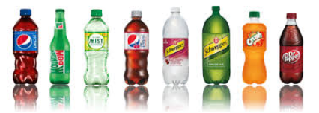

Pepsi ran a promo contest for their 20 oz. bottles of soda. Some of the caps said, “Please try again!” while others said, “You’re a winner!” Pepsi advertised the promotion with the slogan “1 in 6 wins a prize.” Mrs. Gallas’ statistics class wonders if the company’s claim is true. To find out, all 30 students in the class go to the store, and each buys one 20-ounce bottle of the soda. Two of them get caps that say “You’re a winner!”

Does this result give convincing evidence that the company’s 1-in-6 claim is inaccurate?
You and your classmates will perform a simulation to help answer this question.

Question: Are soda contests true? (In this case, does 1 in 6 actually win)

Data Collection: Rolling die simulation
- Find a 6 sided die to roll or look up a rolling die simulation on your phone or computer
- Choose a number that will be a “winner”. For example, if 1 in 6 win, then choose a number that you will roll that is the “winner”. If 2 is my number, then when I roll a 2, that is a winner.
- Roll your die 30 times to imitate the process of the students in Mrs. Gallas’ statistics class buying their sodas. How many of them won a prize?

Analyzing Data (we will do in together next class):
- Plot the number of prize winners you got in Step 1 on the dot plot on the whiteboard. Sketch the class dot plot below.

Conclusion:
What percent of the time did Mr. Wilcox’s statistics class get two or fewer prizes, just by chance?

Does it seem plausible that the company is telling the truth but that the class just got unlucky? Explain.

