Problem #1: Analyzing Data (Pie Charts and Bar Graphs):
Two bags of M&M’s are purchased: one plain and one peanut. Record the color of M&M’s in each bag in the table below:
Color | Plain | Peanut
Orange
Blue
Green
Yellow
Brown
Red

1. Based on the data in the table, do you think the color distribution
is the same in a bag of plain M&M’s and peanut M&M’s

Color | Plain % | Peanut %
Orange
Blue
Green
Yellow
Brown
Red

2. In the table to the right, find the percent of each color
for plain and peanut M&M’s.

3. Create a pie graph based on the percentages for plain and peanut M&M’s.
PLAIN PEANUT

4. Create a side-by-sdie bar graph with color as the categories for both plain and peanut M&M’s.
You do not need to create 2 graphs here, just use one graph and draw 2 bars….one for plain,
one for peanut.

5. After looking at the pie charts and bar graphs, do you think the color distribution is the same in a
bag of plain M&M’s and peanut M&M’s

Problem #2 (Statistical Problem Solving Process):

Question: Do men and women differ in their opinions about the likelihood they will become rich?

Data Collection:
Opinion | Female | Male | Total
Almost no chance | 96 | 98 | 194
Some chance, but probably not | 426 | 286 | 712
A 50-50 chance | 696 | 720 | 1416
A good chance | 663 | 758 | 1421
Almost certain | 486 | 597 | 1083
Total | 2367 | 2459 | 4826

Analyze Data:
- Find the percentages for each opinion category for male and female.
Opinion | Female % | Male %
Almost no chance
Some chance, but probably not
A 50-50 chance
A good chance
Almost certain

- Create a side-by-side bar graph (just like the M&M example) to compare females/males

Almost Some 50-50 Good Almost
None chance chance certain

Conclusion: Based on the data, what can you conclude about the opinions of men and women about their chances to become rich one day?

Problem #3 (Statistical Problem Solving Process):

Question: Do Americans prefer Name Brand or Store Brand Products?
Data Collection:
Table A – Name brand vs. Store Brand Table B – Store brand products sorted by
generation/gender/income
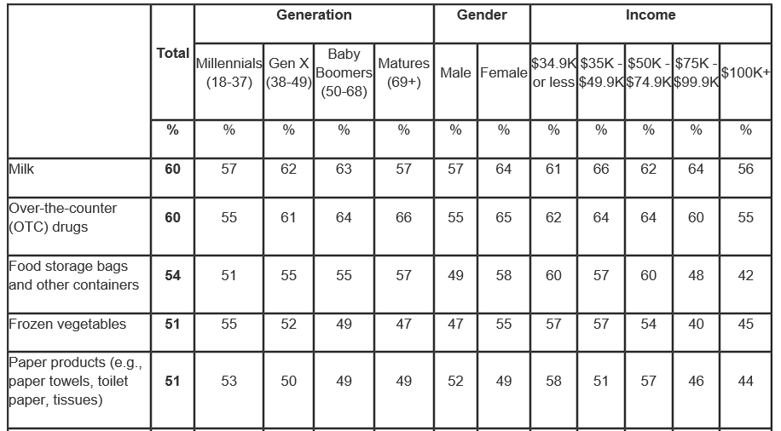
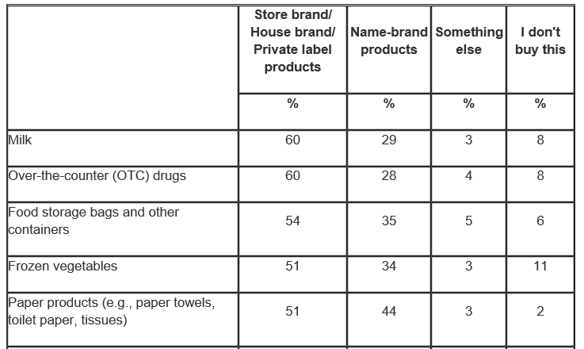
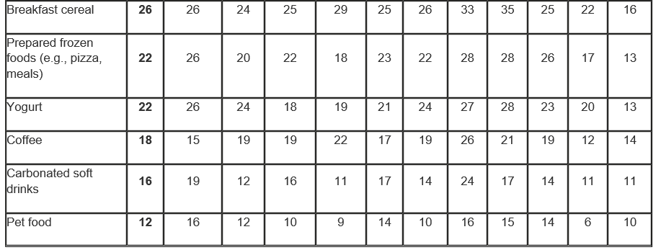
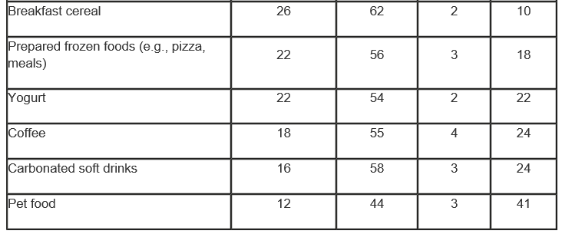

Analyze the data:
Use Table A and create (3) Pie Charts: Paper Products, Cereal, and Carbonated Soft Drinks

Using the product - “Carbonated Soft Drinks” create (3) bar graphs from Table B. One chart for Generation, one for Gender, and one for income.

Conclusion:
Based on the information above, what conclusions can you draw about the question, “Do Americans prefer name brands or store brands?”

