**Statistical Reasoning *e-mail:*** Ed.Morris@cobbk12.org

***Class Syllabus****, Fall**Semester 2020*  ***Remind 101*:** Text @9c9kk3 to 81010

***Office hours:*** Tuesday/Thursday 1:30-2:30pm

**Course Description**: This is the fourth course in a sequence of courses designed to provide students with a rigorous program of study in mathematics. Students will formulate statistical questions to be answered using data, will design and implement a plan to collect the data, will select appropriate graphical and numerical methods to analyze the data, and will interpret their results to answer the initial question.

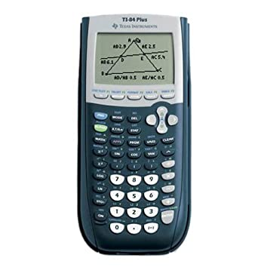

**Supplies:**

1. **Notebook:** have a place to keep all your notes/work organized
2. **Pens/Pencils/Colored Pencils/Highlighters:** Block erasers are also recommended. Colored pencils/Highlighters are optional, but are useful for graphs and shading.
3. **Graphing Calculator:** The TI-84 graphing calculator is ***needed*** for this class

##### See the source image

##### Image result for Image for FlipgridDigital Learning Resources:

##### Digital Learning Expectations: See infographic

**Grading Policy:** COMING SOON!

**Typical Daily Class Schedule:**

10 mins Log-in/Attendance/Warm-up/Welcome activity

10 mins Question/Answer session over previous day lesson – Possible Daily /Skill Check

20-30 mins Present new material/Lab Activities/Class discussion

10-20 mins Student practice/reinforcement of new material

10 mins Closing activity – Possible Daily/Skill Check or TOTD

**Assignments:** Assignments will be posted daily in CTLS. You may be asked to upload some assignments for a grade and some for simply feedback. These tasks will have a due date. Whether graded or not, items assigned are a valuable resource for practice and experience.

**Assessments:** Assessments may come in different forms. There will be a Test at the end of each unit and some units will have Quizzes. Also, daily/skill checks may be given during class time to check student understanding of concepts. You are expected to show your process/work on all assessments. Failure to do so will result in points being deducted from your final assessment grade. You will be monitored during assessments.

**Final Exam**: There will be a “Final” Assessment. This may be in the form of a Final Exam or a Final Project.

**Individual/Small Group Support/Make-Up Work**

Wednesday is the designated day for you to seek help or to make up missing assignments. Think of it as a   
“Virtual Hawk Hour.” You will logon during your regular class time. These sessions last 45 mins.