Vocabulary:
- Statistics –

- Individuals –

- Variables –

- Categorical Data –

- Quantitative Data –

Example 1: The following represents a data set from the Cyber Stat Corporation:
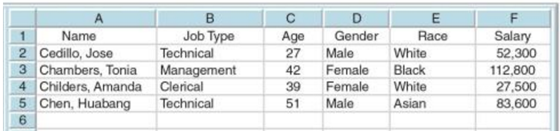
- What are the individuals: b. What are the variables:

- Which data is categorical: d. Which data is quantitative:

Classify each of the following as categorical or quantitative:
- The number of goals scored each week by a soccer team
- The number of children in an Australian family
- The types of pets owned by students in the class
- The number of bread rolls bought each week
- The types of cars students at Hillgrove drive to school

Use good judgement when deciding what variables to consider
Do wealthier people recycle more than others? Researchers weighed the items put out for recycling in two neighborhoods in California
- Who are the individuals?
- What is the variable?

The wealthier households contributed more pounds per week on average than the other households of lower income.
- Are the wealthier more serious about recycling?

