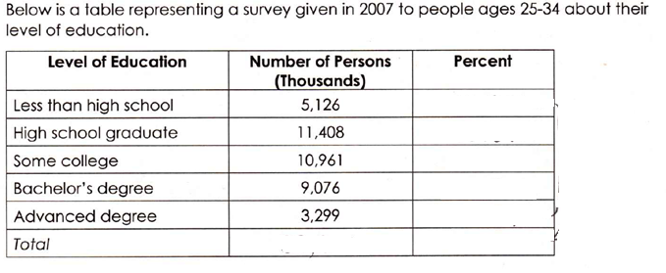
Find the percent for each category. Round to the nearest tenth.
To create a bar graph:
- On the x-axis: the variable
that the data is about
2. On the y-axis: the percents

