Why do we need to a make statistical graphs?

What are we looking for in the graph?
- ____________________________________________________________
- ____________________________________________________________

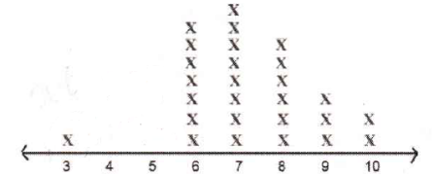
Vocabulary:
- Outlier –

- Center –
Mean
Median
Mode

- Shape –

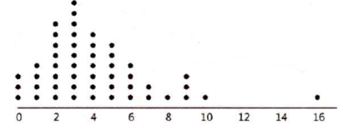
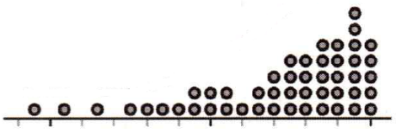
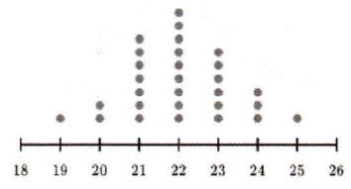

- Spread –
Range
Interquartile Range ()IQR)
Standard Deviation

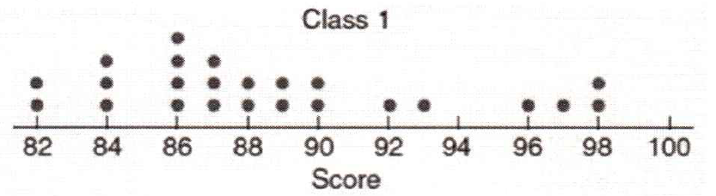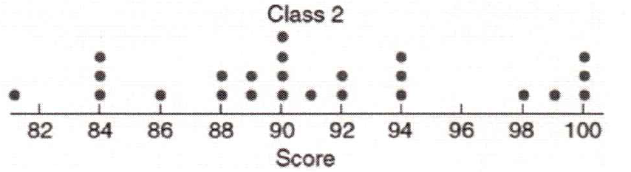

Example 1: Here are data on the number of goals scored in 20 games played by the 2016 U.S. Women’ Soccer Team.
5 5 1 10 5 2 1 1 2 3 3 2 1 4 2 1 2 1 9 3

Create a dotplot. Label and scale the axis. Describe the overall pattern (shape, center, spread, outliers)

Example 2: The EPA is in charge of determining and reporting fuel economy ratings for cars. To estimate fuel economy, the EPA performs tests on several vehicles of the same make and year. Here are data on the highway fuel economy ration for a sample of 25 2018 Toyota 4Runners:

22.4 22.4 22.3 23.3 22.3 22.3 22.5 22.4 22.1 21.5 22.0 22.2 22.7
22.8 22.4 22.6 22.9 22.5 22.1 22.4 22.2 22.9 22.6 21.9 22.4

Create a dotplot. Label and scale the axis. Describe the overall pattern (shape, center, spread, outliers)

Example 3: Here are data on the resting pulse rates (beats per minute) of 19 middle school students.
71 104 76 88 78 71 68 86 70 90 74 76 69
68 88 96 68 82 120

Create a stemplot for the data. Describe the overall pattern (shape, center, spread, outliers)

Example 4: Create a stemplot for the data from Example 2. Describe the overall pattern (shape, center, spread, outliers)

