Angles/Standard Position

Standard position:

* + - * __________________________ - your values are positive.
* __________________________ - your values are negative.

**Finding angle measures:**

* You can keep going around the unit circle more and more times.

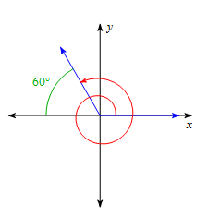Ex. 1

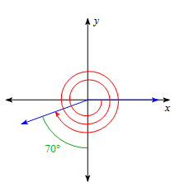Ex. 2

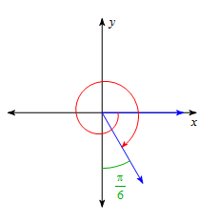Ex. 3

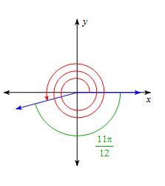Ex. 4

**Sketching & Determining the Quadrant of the Terminal Side of each Angle:**

Ex. 5



Angle:

Quadrant: _____

Ex. 6



Angle:

Quadrant: _____

Ex. 7



Angle:

Quadrant: _____

Ex. 8



Angle:

Quadrant: _____

**Arc Length:** To find the measure of the length of an arc: 

S = arc length; r = radius;  = angle measure **in radians**

Ex 1:  Ex 2:  Ex. 3: 