Density Curves – the total area under a curve is equal to 1. We have already looked at some density curves.

Symmetric Skewed left Skewed right Uniform

Normal Curves – density curves that are symmetric, single-peak, and bell shaped (also known as normal distributions)
Examples of normal distributions:
- Scores on tests taken by many people (SAT, ACT)
- Repeated, careful measurements of the same quanitity (diameter of a baseball)
- Characteristics of biological populations (yield of corn, length of animal pregnancy)

Normal Distributions have the following properties:
- Described by giving the mean and standard deviation
- Mean is the center – located at the center of the symmetrical curve
- Standard deviation determines the shape of the curve – distance from mean to change in curvature of points
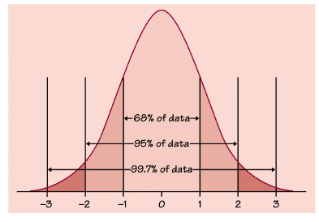
Empirical Rule (68-95-99 Rule)
68% fall within 1 SD
95% fall within 2SD
99.7% fall within 3SD

Further Breakdown:

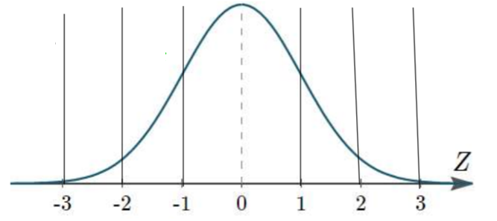

Example 1: Each portion of the SAT is designed to be approximately normal and have a mean of 500 and a standard deviation of 100

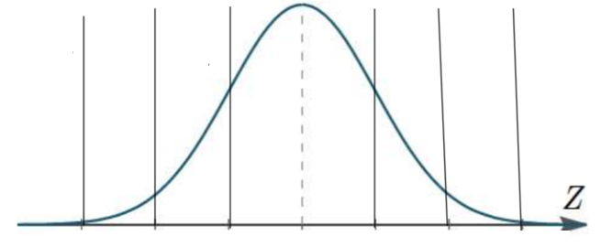

  - What percent of the students will score above 700?

  - What percent of the students will score below 400?

  - What percent of the students will score between 600 and 800?

Example 2: Two hundred students at State University took a Biology test. The scores were distributed normally with a mean of 70 and a standard deviation of 5.

- What percentage of the scores are between 65 and 75?

- What percentage of the scores are between 60 and 70?

- What percentage of the scores are between 60 and 85?

- What percentage of the scores are less than 55?

- What percentage of the scores are greater than 80?

- Approximately how many Biology students scored between 60 and 70? Less than 55?

