Normal Distribution Calculations

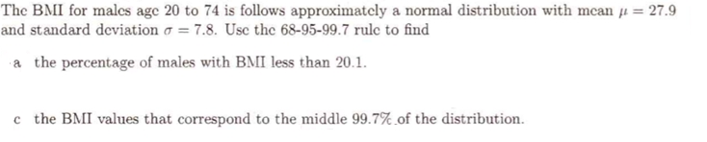

On the driving range, when Tiger Woods hit his driver, the distance the ball travels follows a normal distribution with a mean = 304 yards and a standard deviation = 8 yards.
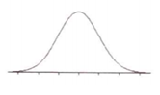

- What percent of drives travel at least 290 yards?

- What percent of drives travel between 305 yards and 325 yards?

- What distance would a ball have to travel to be at the 80th percentile of Tiger’s drive lengths?

