**Standard Normal Distributions**

The 68-95-99 Rule suggest all Normal distributions are the same if we measure units of size  about the mean .

Changing to these units requires us to standardize, so our z-score now becomes: 

Why do we need to standardize? What if we ask for a value that falls between 1 and 2 standard deviations? We have no way to find the exact answer without standardizing because we have no table for the data.

Since we have now standardized the data, we can use the same table for ALL data sets (Standard Normal Table). This table gives us the area under the curve to the LEFT of z.

1) Determine on which test the student had a better score. *(For each student you are determining whether they did better on the stats test or the biology test)*

i. A student received a 73 on the statistics test and a 26 on the biology test.

ii. A student gets a 60 on the statistics tests and a 20 on the biology test.

iii. A student gets a 78 on the statistics test and a 29 on the biology test.

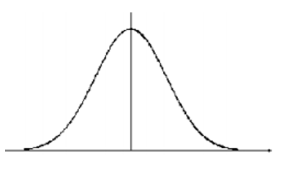Example 1: Find the proportions of observations from the standard normal distribution that are:

1. Less than -1.25
2. Greater than 0.81
3. Between -1.25 and 0.81.

Example 2: Find the z-score that corresponds to the 90th percentile of the standard normal curve.

