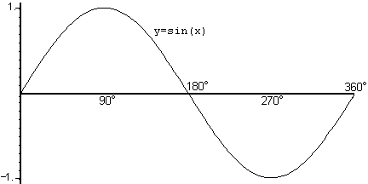 Standard Form: 

a: Amplitude = 

b: Period = 

c: Horizontal Shift (start): (x – c) = 0

d: Vertical Shift = Sinusoidal axis = middle = d

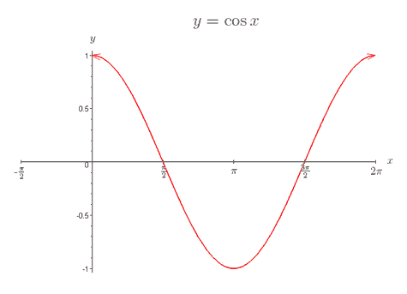

Standard Form: 

Example 1: Graph  Example 2: Graph 

Amplitude:_________Period:_______

Vertical Shift:______

Horizontal Shift_____

Start:_____

End:_____

Increments:____

Amplitude:_________Period:_______

Vertical Shift:______

Horizontal Shift_____

Start:_____

End:_____

Increments:____

