GPS PreCalculus

Guided Notes - Inverse Trig Functions

Inverse of sin:

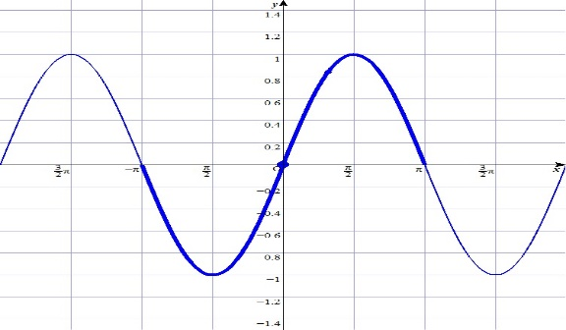

Inverse of cos:

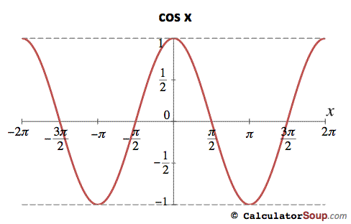

Inverse of tan:

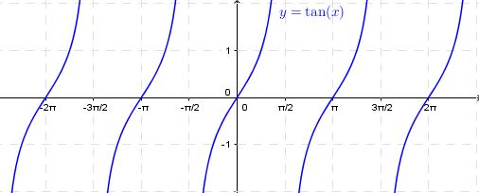

Evaluating inverse trig functions (use Unit Circle)



Examples – Evaluate in degrees and radians:

1.  2.  3.  4. 

Practice: Pg. 288 #1-14, 29-37 odd