Statistical Reasoning Name ____________________________
Notes 4.1: Scatterplots Date _____________________ Day ____

Read through Section 4.1 in the book and answer the following questions.

A scatterplot shows the _________________________between ____________________________ variables measured on the same individuals. The values of one variable appear on the ______________________
Axis and the values of the other variable appear on the _____________________ axis. Each individual appears as a point on the plot.

Example 4.1: Waiting on Old Faithful
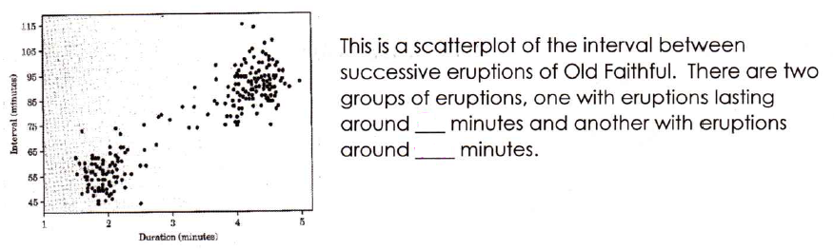

A response variable is a variable that measures __________________________________________________
_________________________________________________________________________________________________

An explanatory variable is a variable that measures ______________________________________________
_________________________________________________________________________________________________

The explanatory variable (if there is one) ALWAYS goes on which axis? ____________________________

Example 4.2: Heavy Backpacks (use the data from the book)
Draw a scatterplot on the grid below to represent the data about the weight of 9th grade boys’ backpacks.

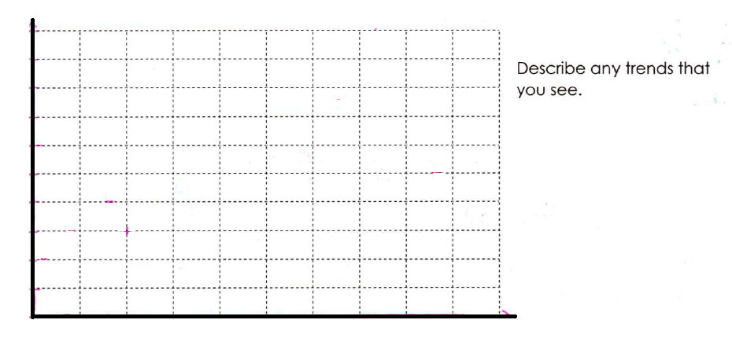
Exercise 4.1 (pg. 147)
- Explanatory: _______________________________ Response: _________________________________

- Explanatory: _______________________________ Response: _________________________________

- Explanatory: _______________________________ Response: _________________________________

- Explanatory: _______________________________ Response: _________________________________

Exercise 4.6 (pg. 149) – Use Table 4.1 – Use the graph below for (a) and (b). Graph points for part (a) in one color and points for part (b) in another color

(c) Describe what you see.

Interpreting Scatterplots (pg. 150)
Examining a scatterplot
As with all data, look for the __________________________________ and _________________________

You describe the overall pattern by:
- _____________________________________
- _____________________________________
- _____________________________________

You describe the deviations by looking at _______________________________________

What does it mean for two variables to be positively associated? Sketch a graph.

What does it mean for two variables to be negatively associated? Sketch a graph.

Statistical Reasoning Name ____________________________
WS 4.1: Scatterplots Date _____________________ Day ____

- In each of the following situations, explain if it is more reasonable to simply explore the relationship between the two variables or to explain the relationship using a response variable and explanatory variable. In the latter case, tell which is the response and which is the explanatory variable.
  - A family’s income and the years of education their eldest child completes

  - Price of a house and square footage of house

  - Arm span and height of a person

  - Amount of snow in the Colorado mountains and the volume of water in the area rivers

- The following diagram shows the school GPA vs. IQ score for all 78 seventh grade students in a rural Midwestern school.
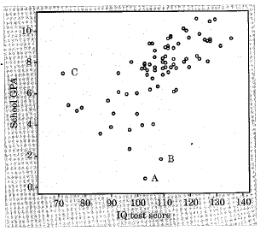
              - Describe the overall pattern of the relationship in words. (Points A, B, and C could be outliers)

              - About what are the IQ and GPA for Student A?

              - For each point A, B, and C, say how it is unusual. (for example, “low GPA but a high IQ).

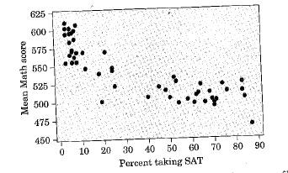
- The following scatterplot shows the mean SAT Math score and the percent of high school graduates who took the SAT in each state during the 2007-2008 school year
              - Describe the overall relationship between the two
variables. Why are there two distinct cluster of
points?

              - Two states stand out: Point A – West Virgina and
Point B: Maine. In what ways are these states “unusual” from the rest of the data.

