Statistical Reasoning Name ____________________________
Guided Notes 4.2: Correlation Date _____________________ Day ____

Correlation
The correlation describes the ____________________ and _____________________ of a straight-line (linear) relationship between two quantitative variables.

Correlation is usually written as r, which we call the _____________________________________________.

Correlation is always between _____ and _____.
If r is positive that means there is a positive association
If r is negative that means there is a negative association
The closer r is to _____________, the stronger the association and the closer to _____ the weaker
the association

Why do we need a correlation coefficient? Consider the following scatterplots.
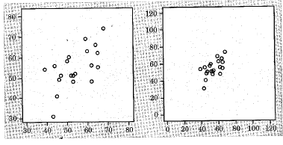

Understanding correlation:
- Correlation does not change when we change units of measurement
- Correlation ignores distinction between response/explanatory variables
- Correlation ONLY measures the strength of straight line associations.
- Correlation is strongly affected by outliers (be careful!)

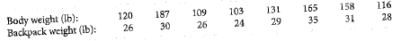
Example 1:

Find the correlation r between the variables.

Statistical Reasoning Name ____________________________
WS 4.2: Correlation Date _____________________ Day ____

- A college student wonders if tall women tend to date taller men. She measures herself, her dorm roomates, and the women in the adjoining rooms; then she measures the next man each woman dates. Here is the data with height in inches.
Women(x) | 66 | 64 | 66 | 65 | 70 | 65 | 67 | 69 | 68
Men(y) | 72 | 68 | 70 | 68 | 71 | 65 | 70 | 72 | 73

- Make a scatterplot of the data.

- Based on the scatterplot, do you expect the correlation to be positive or negative? Near +1 or -1?
- Use your calculator to find the correlation coefficient r.
- How would r change if all the men were 6 inches shorter.

- Does the correlation tell us whether women tend to date men taller than themselves?

- If heights were measured in centimeters rather than inches, how would the correlation change?

- If every woman dated a man exactly 3 inches taller than herself, what would be the correlation between male and female heights?

- List the correlation coefficients in order from weakest to strongest: 0.79, -0.43, -0.4, 0.82, 0.08

- How would you describe a correlation coefficient = 0.87? What about -0.03?

- Describe the correlation:
  - Hours worked at a job and amount of money earned
  - Age of students in the class and their height
  - Age of a Honda Accord and its value over time
  - Temperature and time a cup of coffee is left on the counter
  - Math test score and height
  - Amount of money in the bank and number of days since last paycheck

- Match the graph with the r-value that best describes it.
r = -0.9 r = -0.7 r = -0.3 r = 0 r = 0.3 r = 0.7 r = 0.9

