Statistical Reasoning Name: _____________________________
Review WS: Section 5.1/5.2 Date: __________________ Day: ______

You want to survey students in your school about their exercise habits. Tell whether the following will give you a random sample.

- You select every tenth student on an alphabetical list of students in your school. You survey the selected students in their first period classes.

- At lunchtime you stand by a vending machine. You survey every student who buys something from the vending machine.

Tell whether the following questions are biased or fair. Rewrite biased questions as fair questions.

- Do you think bike helmets should be mandatory for all bike riders?

- Do you prefer the natural beauty of hardwood floors in your home?

- Do you exercise regularly?

- Do you eat at least the recommended number of servings of fruits and vegetables to ensure a healthy and long life?

- Do you prefer the look and feel of thick lush carpeting in your living room?

- Do you take a daily multiple vitamin to supplement your diet?

- Do you read the newspaper to be informed about world events?

- Do you feel that the TV news is a sensational portrayal of life’s problems?

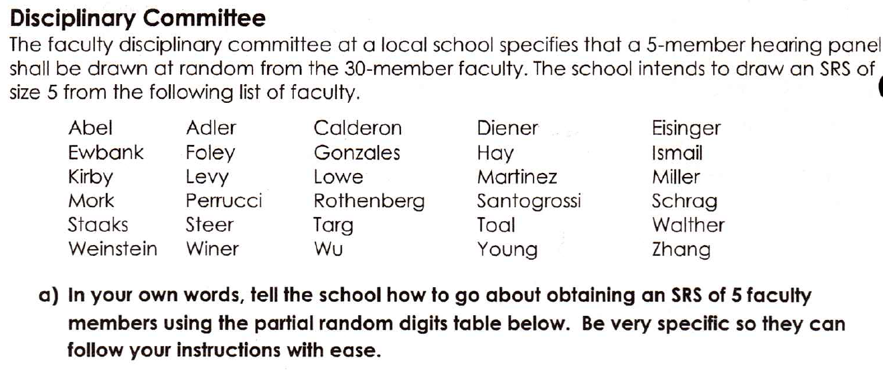

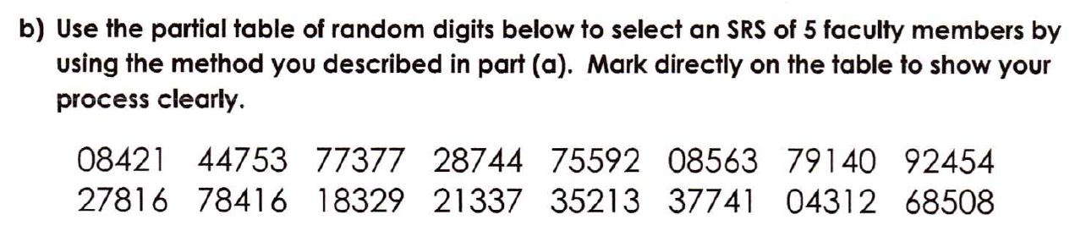

5. Eight citizens are asked their opinions about what trash should be collected.

6. A phone-in survey is taken by a radio station to see how many listeners enjoy jazz in the morning.

7. Every 40th student who enters the school is asked to name their favorite sport.

8. Each math class randomly selects two students to represent their class on an advisory panel being
assembled by the principal.

