Types of Displays
Bar Graph, Pie Graph, Dotplot, Stemplot, Histogram, Boxplot
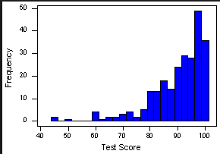
- How would you describe the overall shape of this distribution?
- Where will the mean fall in respect to the median? (don’t try to calculate it)
- What numerical measures would best describe it? mean/standard deviation OR median/IQR)

- Which display best represents categorical data?
- What’s the main difference between the data bar graphs and pie chart can display?

- Use the following data to create a pie chart:
Marital Status | Count (thousands)
Never Married | 23,260
Married | 62,250
Widowed | 10,050
Divorced | 12,100
Total | 107,660

- Create a boxplot for the following data. Describe the shape. Describe any outliers.
Number of text messages sent by teenagers in the last 24 hours:
0 8 2 28 21 7 4 1 23 88 7 1 22
8 120 82 0 91 42 17 2 3 48 7 52

Vocabulary
Median, IQR, 5 numbers summary, Mean, Standard deviation, Outliers, Variability

- A set of data has the following 5-number summary: Min = 15 Q₁= 78 Median= 85 Q₃= 90 High= 95
- What’s the interquartile range?
- Is there an outlier? How do you know?
- What percentage of the data lies above 90?
- What percentage of the data lies below 85?

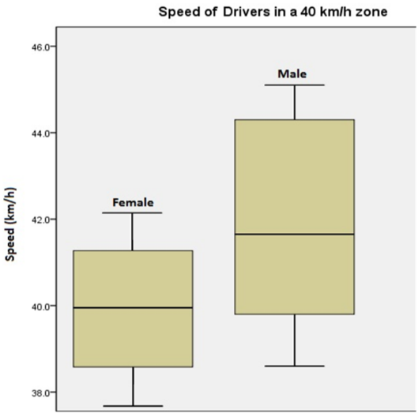
- Use the following boxplot
a. Which one shows more variability?

b. Roughly what percentage of males are going exactly the speed limit or
speeding?

- At a local university, the mean of the total number of classes taken by students earning their Bachelor’s Degree is 35. What does this mean in this situation?
- If all students graduating with a Bachelor’s degree took an extra 3 classes, what would happen to the mean? What would happen to the standard deviation?
- Would anything happen to the median? What about the IQR?

Measures of center and spread
Median/IQR, Mean/Standard Deviation
- Psychologists designed a study involving 47 experienced creative writers who were college students. Students were divided into two groups using a chance process (like drawings name from a hat). One group were given external reasons for writing (like public recognition/making money/pleasing their parents). The other group were given a list of statements about internal reasons (expressing yourself/enjoying working with words). Both groups were then instructed to write a poem about laughter. Each student’s poem was rated separately by 12 different poets using a creativity scale.
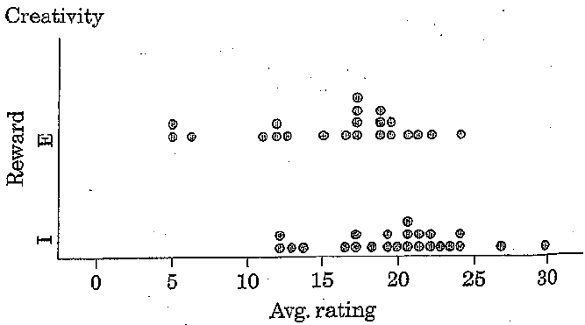
Here’s the data collected during this study:
a) What’s the median of the students who were given external reasons?
b) What’s the median of the students who were given internal reasons?
c) Without calculating it, where would you expect the mean to fall in respect to the median for the students given external reasons?
d) Which one has the most variability? How do you know?
e) Did either one have one or more outliers? How do you know?

- . Mr. Jones and Mrs. Barber give the same history test and the mean result of each class is 85. Mr. Jones claims that even though they got the same average, his class did better overall because his standard deviation was 0 while Mrs. Barber’s was 5. What do you think? Did his students do better? Why or why not?

