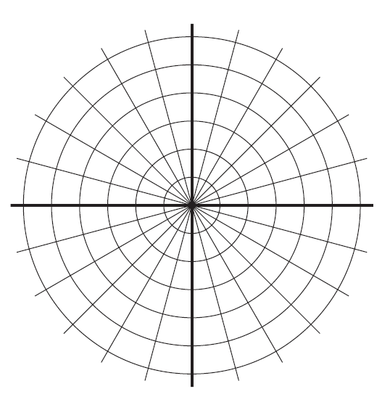

Graph the following polar points:

1. A 
2. B 
3. C 
4. E 

**Find four different pairs of polar coordinates that name the given point if: **

1.  _____________, ______________, _____________
2.  _________________, ___________________, _________________
3.  _________________, __________________, _________________

**Rectangular Coordinates to Polar Coordinates:**

1. (8,10)
2. (-9, -4)

**Polar Coordinates to Rectangular Coordinates:**

1. (3, -120°)
2. (-2, 135°)
3. **Convert from rectangular equations to polar equations:**
4.  13.  14. 

**Convert from polar equations to rectangular equations. Then, identify the resulting figure.**

1.  14. 
2.  16. 

**Represent complex numbers (polar form) & complex number operations:**

1. Explain how you would represent  on the complex plane.
2. Find the conjugate of .
3.  20.  21. 

**Express each complex number in polar form**:

22. 23.

**Convert the polar form of a complex number to its rectangular form:**

24.  25. 

**Cumulative Review:**

26. Solve: 

27. Find the standard form equation of 

28. Evaluate: 

29. Evaluate: 

30. Find , if the angle is in Quadrant II, 

31. Evaluate 

32. Find the asymptotes of 

33. Solve: 

34. Find

35. Find the component form of the vector,

36. An airplane is raveling 300 kilometers per hour due east. A wind is blowing 35 kilometers per hour S 75°W. What is the resulting velocity of the airplane?