Statistical Reasoning Name _________________________________
WS 1.2 Where Do Data Come From Date _______________________ Day _______
Use the following information to answer questions 1 and 2:
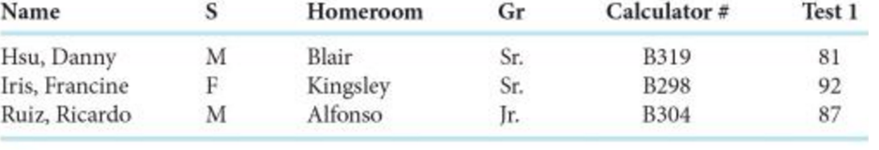
- Who are the individuals
- What are the variables? Identify each as categorical or quantitative.

Use the following to answer questions 3-5:
A high school’s debate team is planning to go to a 3-day competition. Team members are responsible for sharing the hotel cost for two nights. Here is a chart that summarize the hotel information:
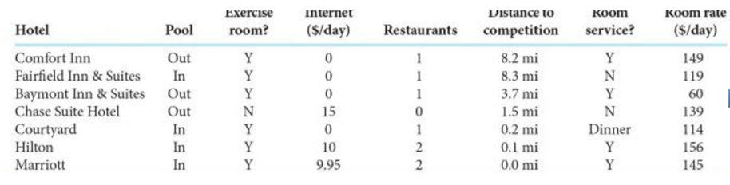

- What are the individuals?

- What are the variables? Identify each as categorical or quantitative.

- If you were a debate team member, which hotel would you recommend? Why?

- In the recycling example from your notes, we decided that weight was not a good measure to determine if a household recycles more than another. What variable could you measure instead?

- Popular magazines rank colleges and universities on their “academic quality.” Describe 4 variables you would use to rate a college or university?

