Statistical Reasoning Name _________________________________
WS 1.4 Date _______________________ Day _______

Observational vs. Experimental
- Before a new variety of frozen muffin is put on the market, it is subjected to extensive taste testing. People are asked to taste the new muffin and a competing brand and to say which they prefer. Is this an observational or experimental study? Explain.

- A teacher asks her students to write down all they eat in a day and then calculate the total number of calories consumed. Is this observational or experimental?

- The cafeteria manager of a high school wants to find out if high prices are keeping student from using the cafeteria. Fifty students are chosen at random to receive help-price lunch passes every day for a month. The manager then records the number of passes used. Is this observational or experimental?

- My grandmother once told me the color red makes bees angry. Here is a method I have designed to test her claim: Select half my students to wear white clothes and the other half to wear red clothes. Then, let a bunch of bees loose in the classroom and record how many time each student gets stung.
  - Observational or Experimental?
  - What are the variables?
  - If students wearing red clothes are stung much more, can we conclude that the color red causes bees to get angry?
  - Are there any flaws or issues with this study?

- Compare the grades of 25 math students who used a calculator on their final exam vs. 25 students who did not use a calculator. Observational or Experimental?

- Determine which brand of orange juice people prefer. Participants are asked to taste both brands with knowing which brand they are tasting. Observational or Experimental?

- To determine whether a review session will help students scores on a Math Test, a teacher divides her class into two groups. One group is required to attend a study session. The grades on the test for both groups are then compared. Observational or Experimental?

- Many people eat fast food as a regularly. Is fast food unhealthy? The best answer may be it depends on what you eat. The following table lists nutritional facts about popular fast food burgers:
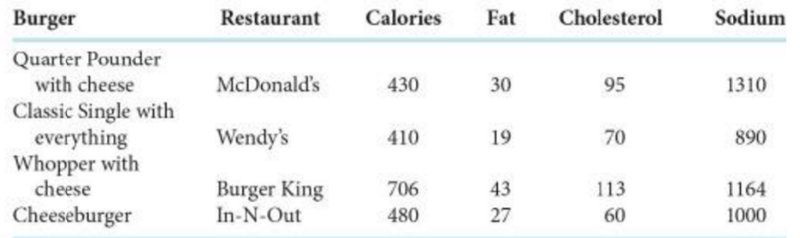
  - What are the individuals?

  - What are the variables?

c. Are fast food chicken sandwiches healthier than burgers? Use the internet and find some data
on a popular fast food chicken sandwich.
Sandwich | Restaurant | Calories | Fat | Cholesterol | Sodium
Populations vs. Samples
Identify each of the following data sets as either: (P) Population or (S) Sample
_______1. ….the age of a few randomly selected participants in a study about a race of runners
_______2. ….the annual salary of each full-time teacher in a study about Phoenix High School
_______3. ….a survey of 750 Georgia homeowners in a study about all of Georgia’s homeowners.

4. A beverage company wanted to see if people in the United States liked their new logo. Which choice best represents a population?
A. A selection of logo artists.
B. Every person in the United States.
C. A selection of shoppers from different states.
D. 3,800 children age 5 – 15

5. A musician wanted to see what people who bought his last album thought about the songs. Which choice best represents a sample?
A. Every person who bought the album.
B. A selection of people who didn't want to buy the album.
C. 250 girls who bought the album.
D. A selection of 3,294 people who bought the album.

6. A gaming website wanted to find out which console its visitors owned. Which choice best represents a population?
A. Visitors to the 3DS section.
B. All of the website visitors.
C. Visitors to the PS4 section.
D. Visitors who are on the website for more than 5 minutes.

7. Before a nation wide election, a polling place was trying to see who would win. Which choice best represents a sample?
A. A selection of voters over age 50.
B. A selection of male voters.
C. A selection of voters of different ages.
D. All voters.

8. A toy store owner tracking how much kids spend each month on toys. Which choice best represents a population?
A. All of the kids who buy toys.
B. 227 rich kids.
C. 228 boys age 7 - 15
D. 235 kids from age 10 to 15.

