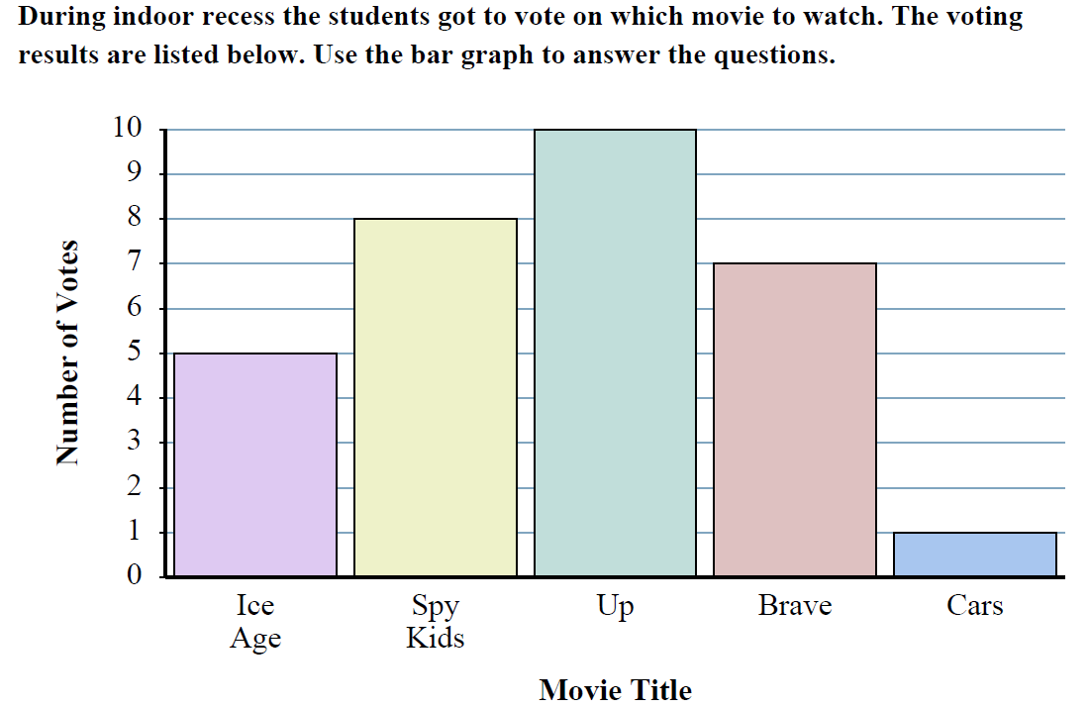
- How many voted for Ice Age?
- Did more people vote for Ice Age or Up?
- Did fewer students vote for Cars or Brave?
- Which movie received exactly 10 votes?
- What is the difference between the number students who voted for Brave and Spy Kids?
- How many students voted for Up and Brave?
- Which movie received the most votes?
- Which movie received the fewest votes?

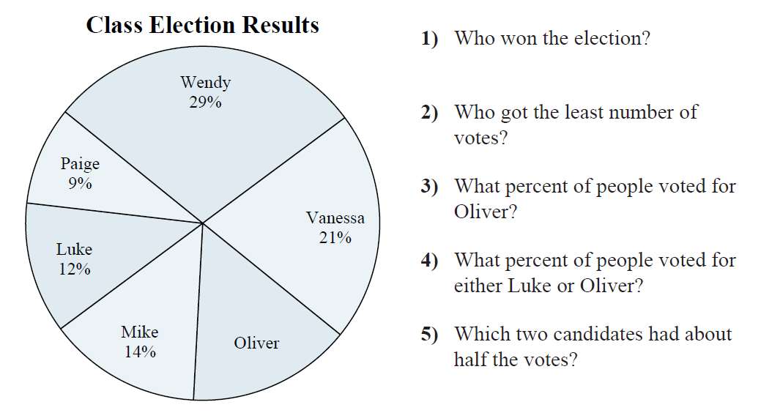
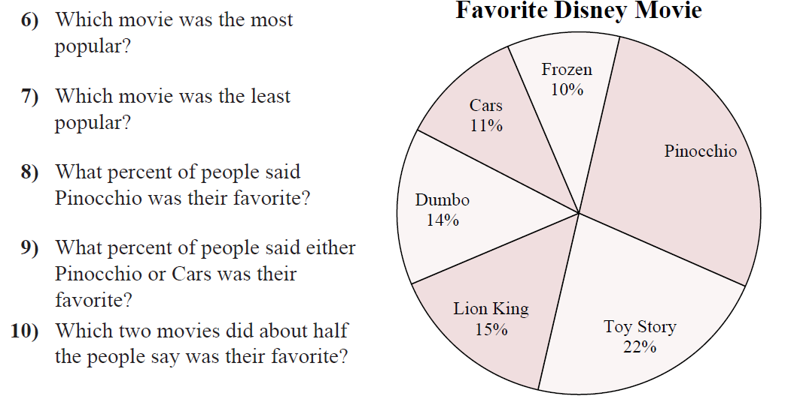

- In the Statistical Abstract of the United States, we find these data on the marital status of adult American women as of 2007:
Marital Status | Count (thousands)
Never Married | 25,262
Married | 65,128
Widowed | 11,208
Divorced | 13,210
Total | 114,807

- How many women were not married in 2007?
- Make a bar graph to show the distribution of marital status.

- Can you create a pie chart from the data? If so, make a pie chart for the data.

- Is it true that girls perform better than boys in the study of languages and so-called soft sciences? Here are several AP subjects and the percent of exams taken by female candidates in 2007:
English Language/Comp | 63%
French Language | 70%
Spanish Language | 64%
Psychology | 65%
- Why can we NOT use a pie chart to display this data?

- Make a bar graph of the data (order the bars smallest to largest)

- Do these data answer the question about whether girls perform better in these subject areas?

- The following table summarizes the percent of each group who said they “Always” or “Sometimes” use cell phones while driving:
Generation Y | Generation X | Baby Boomers | Matures
86% | 79% | 76% | 48%

- Can you use a pie chart to display this data? If yes, the do it. If no, then explain.
- Make a bar graph of the data.

- States sell lots of lottery tickets. The following table shows where the money comes from. Make a bar graph and a pie graph displaying the data.
Game | Sales (millions of $$)
Instant Games | 29,736
Three-digit games | 5,586
Four-digit games | 3,499
Lotto | 10,014
Other | 3,579
Total | 52,414

