1. 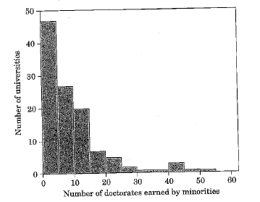The figure below is a histogram of the number of minority students who earned doctorate degrees in engineering from each of the 115 universities over a 5 year period. Describe the shape, center, and spread of this distribution.
2. 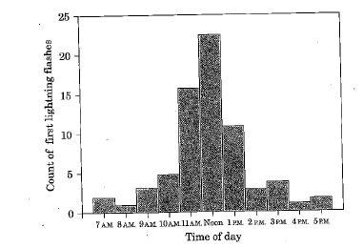The figure below comes from a study of lightning storms in Colorado. It shows the distribution of the hour of the day during which the first lightning flash for that day occurred. Describe the shape, center, and spread of this distribution. Are there any outliers?
3. Joe made the histogram shown below from some poverty data he obtained. Explain why Joe’s histogram is not legitimate.



1. Test scores out of 100 points

92 84 95 77 74 80 95 70 66

73 68 90 78 64 72 78 76 65

59 71 77 92 91 89 74 76 90

Frequency table:

|  |  |
| --- | --- |
| Interval | # of values (frequency) |
|  |  |
|  |  |
|  |  |
|  |  |
|  |  |
|  |  |
|  |  |
|  |  |
|  |  |

|  |
| --- |
|  |
|  |
|  |
|  |
|  |
|  |
|  |
|  |
|  |
|  |

1. The data below represents the percent of state residents living in poverty in 2007.

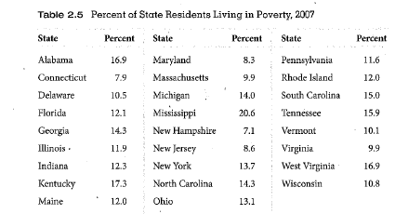

1. Make a histogram of the data use seven classes of width 2. Begin with the class 7-9

|  |  |
| --- | --- |
| Interval | # of values (frequency) |
|  |  |
|  |  |
|  |  |
|  |  |
|  |  |
|  |  |

|  |
| --- |
|  |
|  |
|  |
|  |
|  |
|  |
|  |
|  |
|  |
|  |

Frequency table: