- You read that the median income of U.S. Households in 2007 was $50,233. Explain what “median income” means.

- Here are the scores of Mrs. Liao’s students on their first statistics test:
93 93 87.5 91 94.5 72 96 95 93.5 93.5 73 82 45 88
80 86 85.5 87.5 81 78 86 89 92 91 98 85 88 43

a. Find the 5 number summary
1. What does the median number mean in this example.
2. What does the IQR mean in this example.

b. Are there any outliers?
c. Make a boxplot of the data.

- After hearing about the text message study, Mrs. Krebs asked her students in her stats class how many phone calls they had made or received in the past 24 hours. Here are their responses:
3 0 12 10 8 4 2 7 10 11 6 7 35
12 3 10 2 7 9 15 5 14 15 6 0

a. Find the 5 number summary
1. What does the median number mean in this example.

2. What does the IQR mean in this example.

b. Are there any outliers?
c. Make a boxplot of the data

- The figure below shows the difference (texts-calls) between the number of phone texts and calls sent or received in the last 24 hours from Mr. Williams math class.

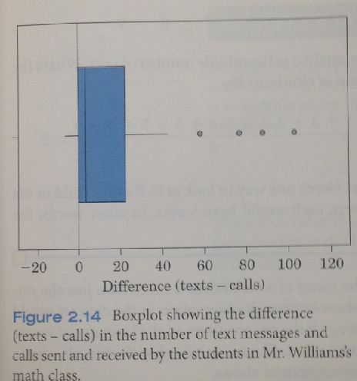

  - Estimate the 5 number summary from this data.

  - Interpret the value of Q1, Median, and Q3 in this setting.

  - Do Mr. Williams students seem to prefer texting or talking?

