Mean/Median?
If data is symmetric – use mean and standard deviation (why? Data not affected by extremes; balanced)
If data is skewed left/right, use median and quartiles

- The following dotplot shows data for the number of music CD’s owned:
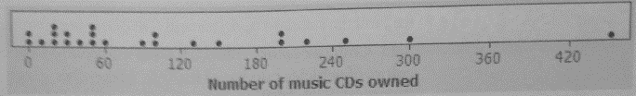

- Which would better summarize the center and the spread: median/quartiles or mean/standard dev.?
Justify your answe

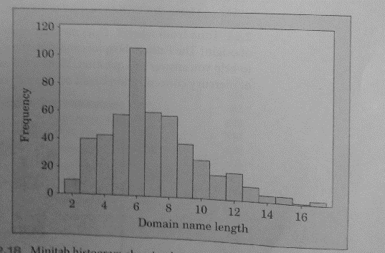
- Are shorter internet domain names better? Below is the histogram for the 500 most popular Web sites.

- Estimate the mean and median of the distribution.
- If you wanted to argue that shorter domain names are more popular, which measure of center would you use – the mean or the median? Justify your answer.

- Does mercury content in canned tuna differ by country of origin? Use the boxplot below to write a few sentences comparing the distributions.
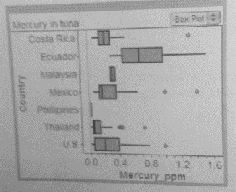
- Electoral votes: To become President of the United States you must win a majority of the electoral votes that are cast in the Electoral College. The following is a stemplot of the number of electoral votes for each of the 50 states and the District of Columbia.
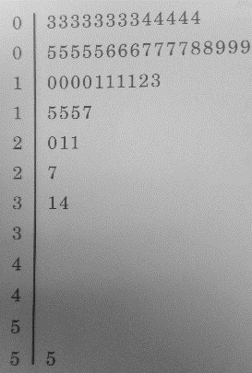
- Find the 5 number summary

- Are there any outliers?

- Make a boxplot of the data.

- Which measures of center/spread would you use to summarize the data (mean/s or med/quart)?

- You are planning a party and want to know how many cans of soda to buy. Would you rather know the median number of cans a person will drink or the mean number of cans? Explain.

- A school system employs teachers at salaries between $18,000 and $40,000. If every teacher is given a $1,000 raise, what will happen to the:
  - mean salary
  - median salary
  - quartiles
  - standard deviation

