- According to the Los Angeles Times, speed limits on California highways are set at the 85th percentile of vehicle speeds on those stretches of road. Explain what that means.

- William is a star runner on the track team, and Taylor is one of the best sprinters on the swim team. Both athletes qualify for the league championship meet based on their performance during the regular season.
  - In the track playoffs, William records a time that would fall at the 80th percentile of all his race times that season. But his performance places him at the 50th percentile in the league championship meet. Explain how this is possible.

  - Taylor swims a bit slowly for her in the league swim meet, recording a time that would fall at the 50th percentile of all her meet times that season. But her performance places Taylor at the 80th percentile in this event at the league meet. Explain how this could happen.

- Individuals with low bone density (osteoporosis) have a high risk of broken bones. Physicians who are concerned about their patients can refer for testing. Currently the most common testing method is dual-energy X-ray absorptiometry (DEXA). Francine, who is 25 years old, has her bone density measured using DEXA. Here results show a bone density of 948 g/cm² in her hip area which converts to a z-score of -1.45. In the reference population of 25 year old woman like Francine, then mean bone density is 956 g/cm².
  - What does Francine’s z-score tell her about her bone density?

  - Use the information provided to calculate the standard deviation. (use your z-score formula and use x as Francine’s score)

- One of Francine’s friends, Louise, has her bone density measured using DEXA. Louise is 35 years old. Her bone density is also reported as 948 g/cm², but her z-score = 0.50. The mean bone density for the reference population of 35 year old women is 944 g/cm².
  - Whose bones are healthier – Francine or Louise? Explain.
  - Calculate the standard deviation from Louise’s population. How does it compare to Francine’s population? Does this make sense?

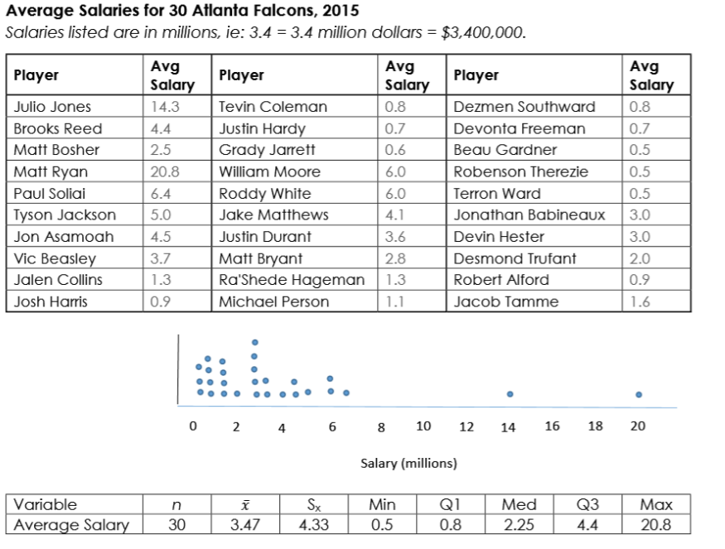
- Find the percentile for Devin Hester’s salary. Explain what this means.

- Find the z-score corresponding to Hester’s salary. Explain what this means.

- Does Desmond Trufant have a high salary or a low salary compared with the rest of the team? Justify your answer using Trufant’s percentile and z-score.

- Which player has a z-score close to 2.5?

- Which player has a z-score close to -1?

- Describe the distribution of the 30 Atlanta Falcon average salaries.

