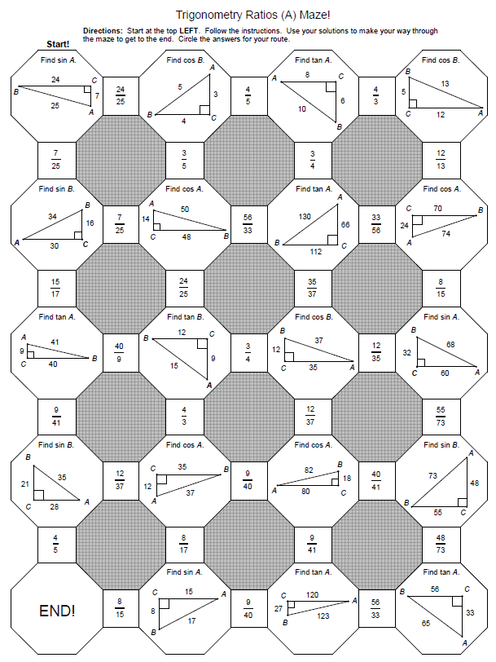

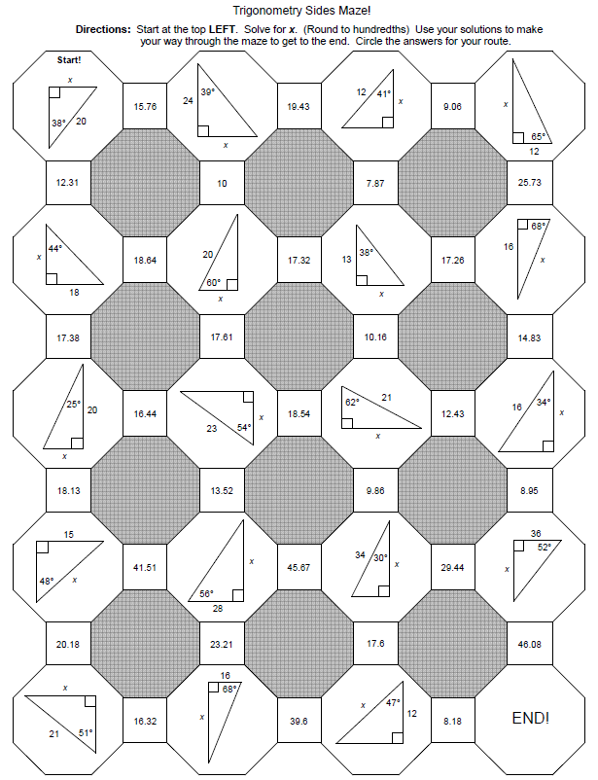

Angle of Elevation & Angle of Depression

1. A bird watcher is standing 50 feet from the base of a large tree. The surveyor measures the angle of elevation to a bird on top of the tree as 71.5°. How tall is the tree?

2. The angle of depression from the top of a tower to a boulder on the ground is 38º. If the tower is 25m high, how far from the base of the tower is the boulder?

3. A rocket is launched at an angle into outer space. After a minute, the rocket traveled 5 miles and had an altitude of 3.5 miles. What is the angle of elevation that the rocket was launched at?

4. Your car is driving up a hill that is 500 feet long at an angle of elevation of 15º. What is the vertical distance covered by your car to the nearest foot?

5. A construction worker leans his ladder against a building making a 60º angles with the ground. If his ladder is 20 feet long, how far away is the base of the ladder from the building?

6. The bottom of a double rainbow is going over a tree that is 18 feet tall. If you’re standing 20 feet from the tree, what is the angle of elevation to the bottom of the rainbow?

