Name: ______________________________  
Period: _____________ Date: ___________

Statistical Reasoning  
WS 3.4: Empirical Rule Practice

1. A competency test score has a mean of 80 and a standard deviation of 10.
2. 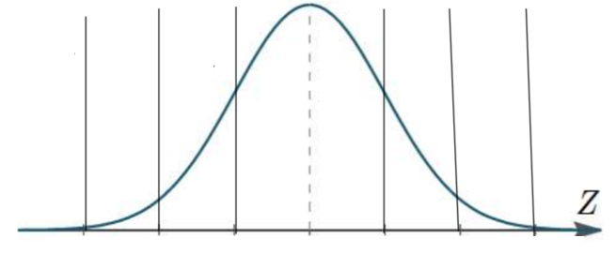Sketch the distribution.
3. Between what two scores do the middle 68% fall?
4. Between what two scores do the middle 99.7% fall?
5. How high must you score to be considered in the top 2.5%?
6. The Army reports that the head circumferences among soldiers is approximately normal with a mean of 22.8 inches and a standard deviation of 1.1 inches.
7. What percent have a head circumference greater than 23.9?
8. What percent have a head circumference between 21.7 and 23.9 inches?
9. What percent have a head circumference less than 26.1?
10. The length of human pregnancies from conception to birth varies according to a distribution that is approximately normal with a  days and  days.
    1. Sketch the distribution.
    2. Between what values do the lengths of the middle

68% of pregnancies fall?

* 1. How short are the shortest 16% of all pregnancies?
  2. What percent of pregnancies last between 234 and 314 days?

1. SAT verbal scores are normally distributed with mean of 450 and standard deviation of 120.
   1. What percent of the scores lie between 210 and 690?
   2. What percent of the scores lie between 450 and 570?
   3. What percent of the scores lie between 450 and 690?
   4. What percent of the scores lie between 210 and 570?
   5. What percent of the scores were above 690 and below 210?