Statistical Reasoning

Guided Notes 3.6: Standard Normal Distributions

**Standard Normal Distributions**

The 68-95-99 Rule suggest all Normal distributions are the same if we measure units of size  about the mean .

Changing to these units requires us to standardize, so our z-score now becomes:



Why do we need to standardize? What if we ask for a value that falls between 1 and 2 standard deviations? We have no way to find the exact answer without standardizing because we have no table for the data.

Since we have now standardized the data, we can use the same table for ALL data sets (Standard Normal Table)

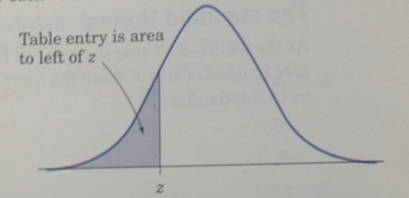This table gives us the area under the curve to the LEFT of z.

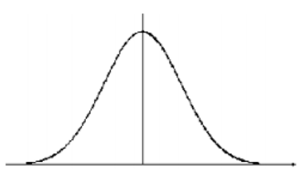Example 1: Find the proportions of observations from the standard normal distribution that are:

1. Less than -1.25
2. Greater than 0.81
3. Between -1.25 and 0.81.

Example 2: Find the z-score that corresponds to the 90th percentile of the standard normal curve.



Statistical Reasoning Name ____________________________

WS 3.6: Standard Normal Distributions Date _____________________ Day ____

For All problems use Standard Normal Table to find the answers.

1. Z-score less than -0.37? greater than -0.37?
2. Z-score less than 2.15? greater than 2.15?
3. Z-score less than -1.58?
4. Z-score greater than 0.93?
5. Z-score between -1.33 and 1.65?
6. Z-score between 0.50 and 1.79?
7. Z-score between -2.05 and 0.78?
8. The 20th percentile of the standard normal distribution.
9. Find the z-score such that 45% of all observations are greater than. (Hint: find the % of observations less than)
10. The 63rd percentile of the standard normal distribution.
11. 75% of all observations are greater than z.