Statistical Reasoning Name:
WS 4.3 - Correlation Practice
Match the following graphs with their corresponding correlation coefficient value:

- -0.015 _____ B. -0.996 _____ C. 0.778 _____ D. -0.728 _____

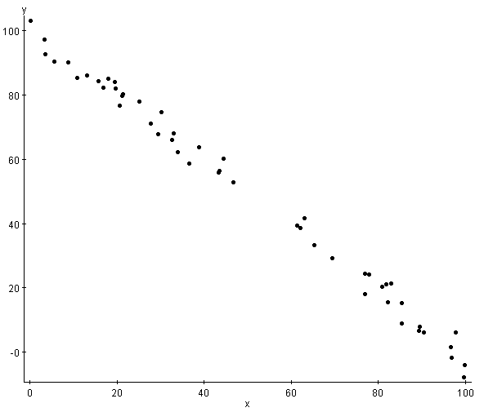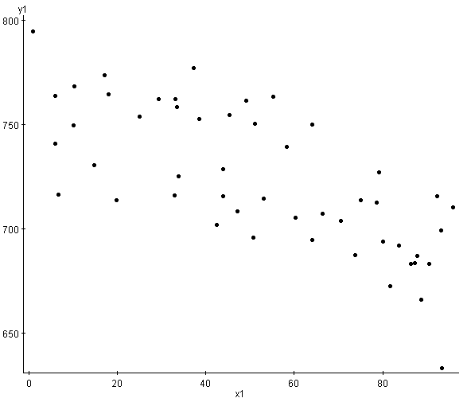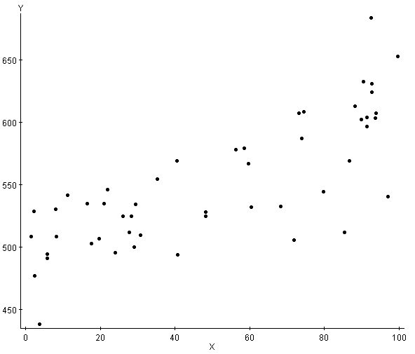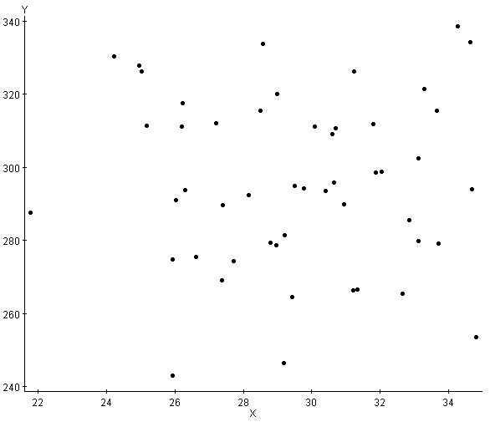

1 2 3 4

- 0.341 _____ B. 0.855 _____ C. 0.999 _____ D. -0.721 _____
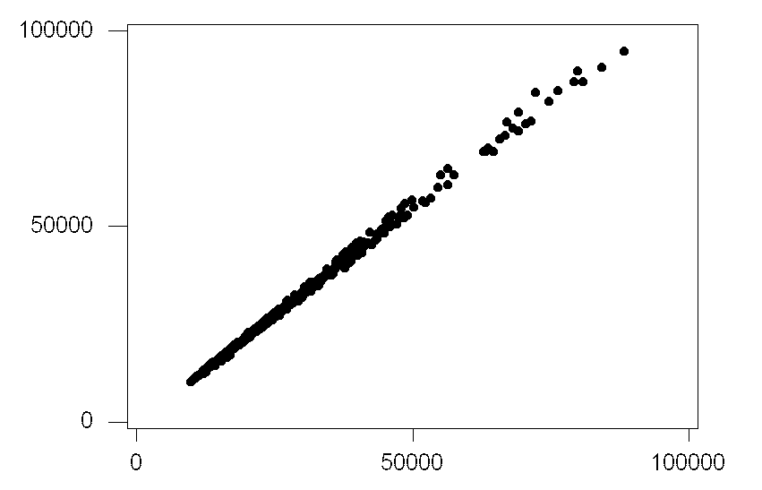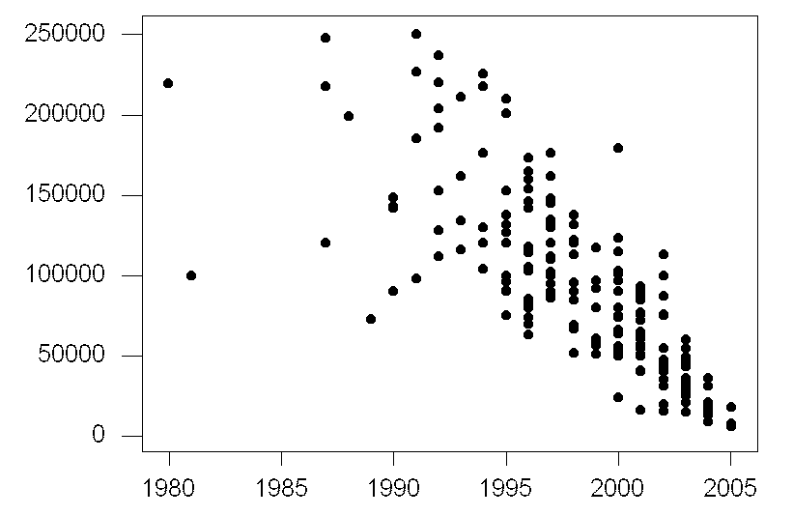
1 2

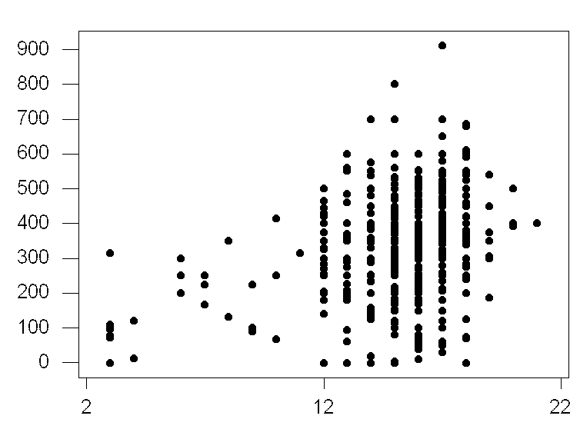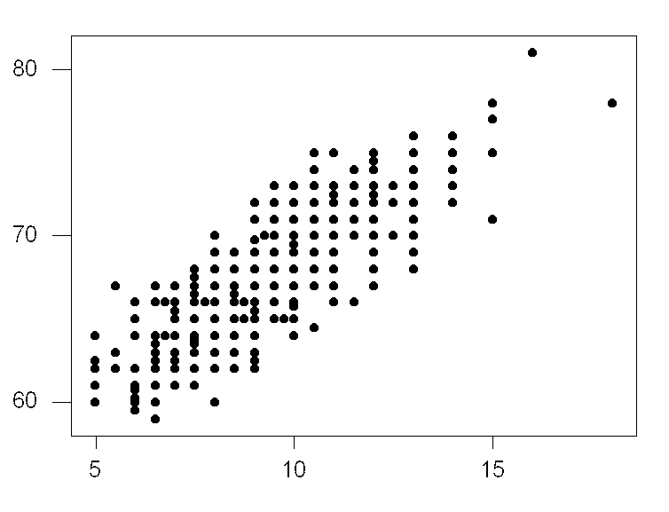
3 4

Match the following graphs with their corresponding correlation coefficient value:

- 0.3006 B. -0.1158 C. 0.1276 D. -0.4399
E. -0.3619 F. -0.6291 G. 0.941 H. 0.8345

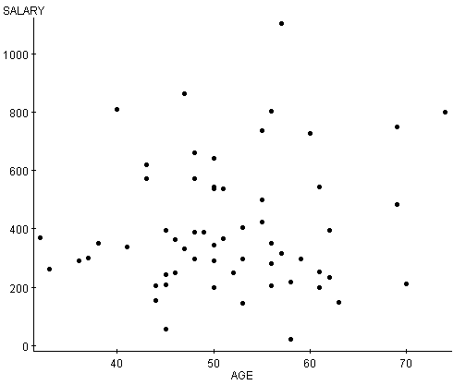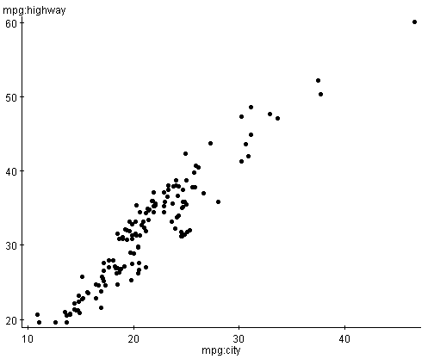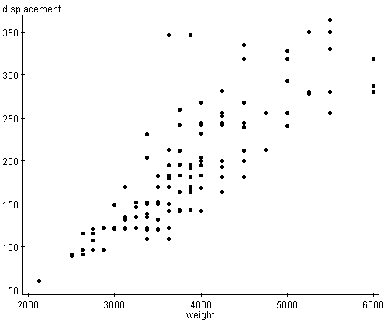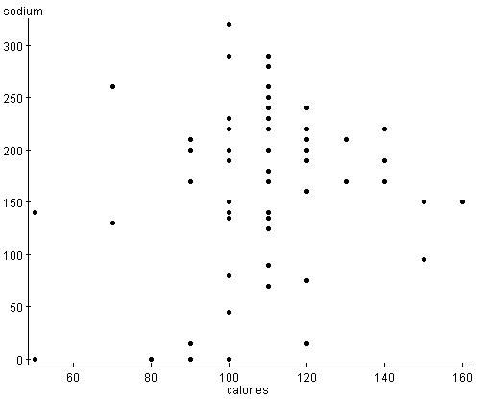
1 2 3 4
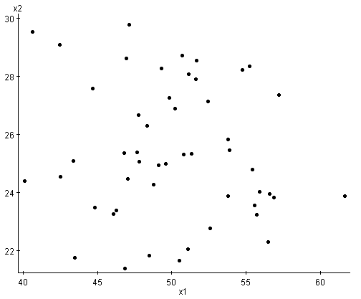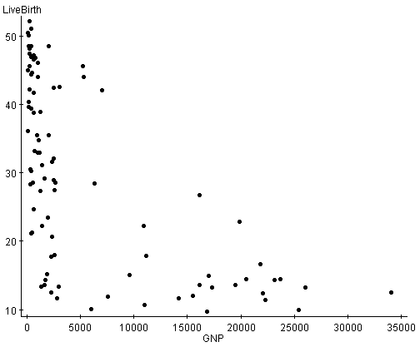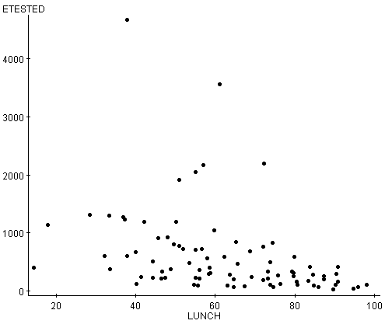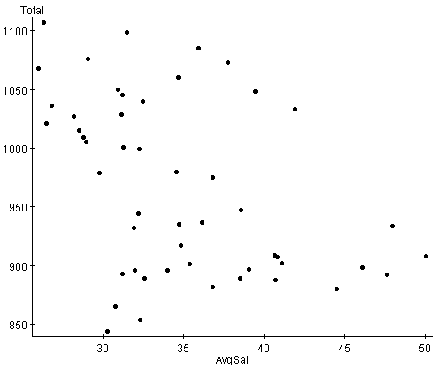
- 6 7 8

For each of the scatterplots, describe the relationship using one of the following descriptions:
- Strong positive correlation
- Weak positive correlation
- Strong negative correlation
- Weak negative correlation
- No correlation

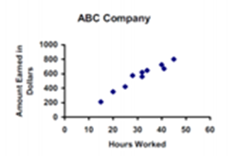
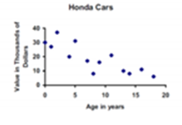

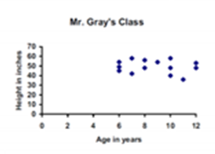
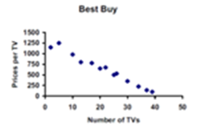

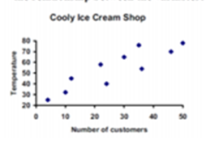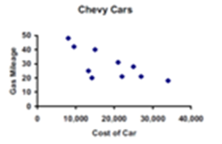

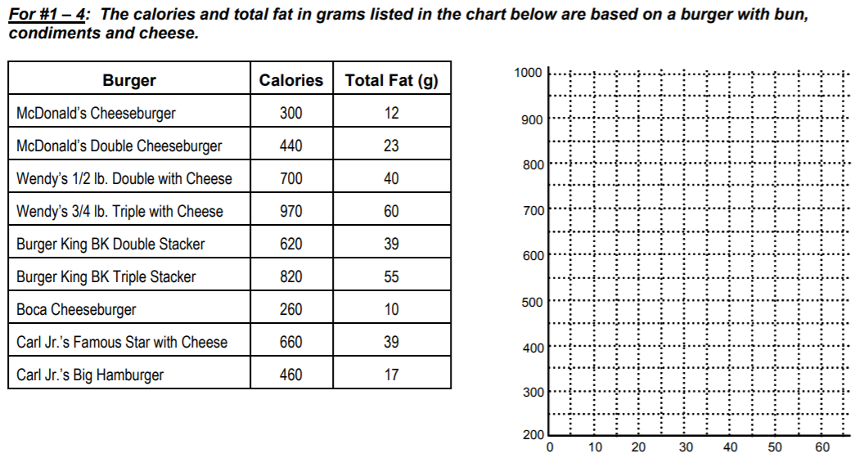

1. Do you think calories explains fat or fat explains calories?
Therefore, fat is the ___________________ explanatory variable and calories is the
____________________ response variable.

2. Plot the ordered pairs on the grid above. Be sure to put the explanatory on the x-axis and the response on the y-axis.

3. Describe the relationship between the two variables.

4. Are there any outliers?

5. Use the data to find r (correlation coefficient): __________ (type your explanatory into L₁ and your response into L₂)

6. If we changed the fat content into milligrams instead of grams, what would happent to r?

7. If we added 1 slice of cheese to each burger it would increase the calories by 70 and the total fat by 5(g). What effect
would this have on r?

8. What if Boca Cheeseburger only had 160 calories. How would this effect r? Would r be larger, smaller, no change?

Use the following date to answer questions #9-12
9. _____________________ is the explanatory variable.
_____________________ is the response variable.

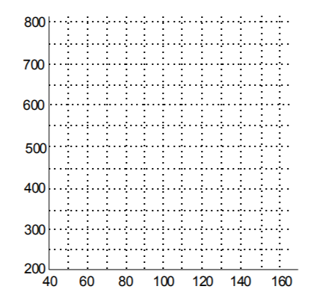
10. Plot the ordered pairs on the correct axis.
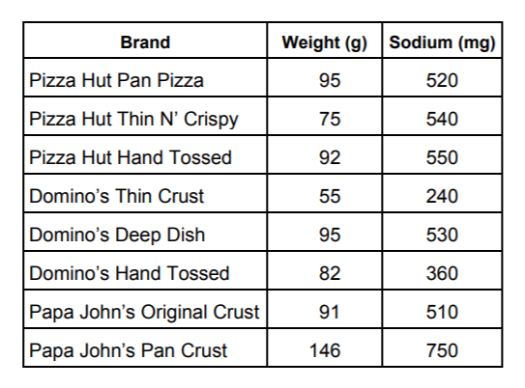

11. Describe the relationship between the two variables.

12. Find the correlation coefficient (r)

