Statistical Reasoning Name __________________________________
WS 4.4: Linear Regression Date _____________________ Day _________

Create a scatterplot, find the linear regression equation, determine the correlation, and then make a prediction.

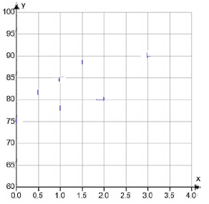
- The table below gives the amount of time students in a class studied for a test and their test scores.
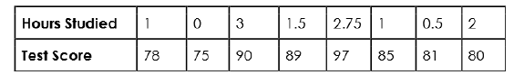

- Draw the scatterplot

- Find the linear regression equation:

- What does the slope mean in this context.

- r = ______________

- Describe the correlation. Is it weak, moderate, strong?

- r² = _________________. What does this tell you about your linear regression equation?

- Using the linear regression equation, predict a student’s score if they studied for 4 hours.

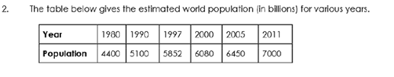
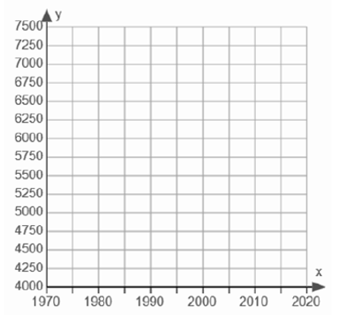

- Find the linear regression equation:

- What does the slope mean in this context.

- r = ______________

- Describe the correlation. Is it weak, moderate, strong?

- r² = _________________. What does this tell you about your linear regression equation?

- Using the linear regression equation, predict what the population will be in 2015.

- The table below shows the percentage of females in the US labor force throughout various times in history:
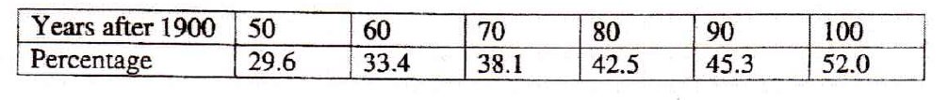
- Find the linear regression equation. (round slope and y-intercept to 2 decimal places)

- What is the meaning of the slope? Of the y-intercept?

- Using your equation, what was the percentage of women working in 2010? 2019?
(be careful what value you enter for x - # years after 1900)

- Find r. What does it mean?

- Find r². What does it mean?

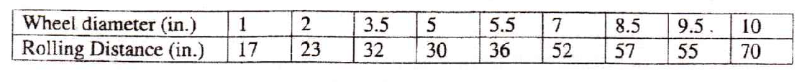
- Recently Adam put larger wheels on his skate board to see if it would coast farther. He tested his theory and found the following data.

- Find the linear regression equation. (round slope and y-intercept to 2 decimal places)

- What is the meaning of the slope? Of the y-intercept?

- Using your equation, what was the percentage of women working in 2010? 2019?
(be careful what value you enter for x - # years after 1900)

- Find r. What does it mean?

- Find r². What does it mean?

