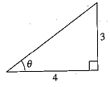**Double Angles**

Use the figure to find the exact value of the trig function:

1. 
2. 
3. 

Find the exact value of sin 2u, cos 2u, and tan 2u using the double angle formulas.

1. 
2. 

**Verifying Identities Practice:**

1.  2. 
2.  4.

5.  6. 

1.  8. 
2.  10. 