Students in Ms. Smith’s Homeroom were polled to find out how many of them owned an IPhone and/or an IPad. The Venn diagram below shows the results:

Students in Mrs Smith’s Homeroom:
IPhone
IPad

5
2
11

9

- What facts can we determine from the Venn Daigram?

  - How many students only have an Iphone?

  - How many students only have an IPad?

  - How many students nave neither?

  - How many students are in Mrs. Smith’s homeroom?

- If a student is selected randomly, find the proability that:

  - The student has both

  - The student has neither

  - The student has either an IPhone or IPad

  - The student has an IPad, given that they don’t have an IPhone

The following Venn diagram shows what the members of the literature club read over the summer:
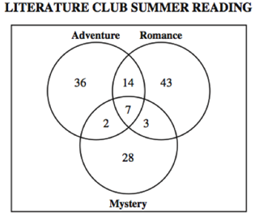
- If a student is selected at random, find the following probability that the student read :

  - A mystery

  - A romance or adventure

  - All three types

  - Neither romance nor mystery

A college surveyed 1125 freshman students about which meals they ate in the school cafeteria. The findings were as follows:
25 ate only breakfast, 15 ate only lunch, 50 ate only dinner, 60 ate only lunch and breakfast, 225 ate only lunch and dinner, 500 ate only dinner and breakfast, 240 ate all three meals in the cafeteria.
- Fill in the Venn Diagram
lunch
breakfast

dinner

- If a student is selected at random, find the following probability that the student:

- Ate only breakfast

- Ate breakfast & lunch but not dinner

- Ate at least 2 meals

- Ate only 1 meal

- Ate exactly two meals

- Did not eat in the caferteria

- The two-way table describes 595 students who responded to a school survyer about eating breakfast. Construct a Venn Diagram of these dats using Event B=eats breakfast regularly and Event M=is male.
 | Male | Female | Total
Eat breakfast regularly | 190 | 110 | 300
Don’t eat breakfast regularly | 130 | 165 | 295
Total | 320 | 275 | 595

