Name: ________________________________________________ Date: _______________________

Simple Probability Events
- A class tossed coins and recorded 161 heads and 179 tails. According to the data, what is the probability of flipping tails?

- A jar contains 30 red marbles, 50 blue marbles, and 20 white marbles. You pick one marble from the jar at random.
  - P(red) b. P(blue) c. P(not white) d. P(red or blue

Use the general addition rule to compute the probability that if you roll two six-sided dice.
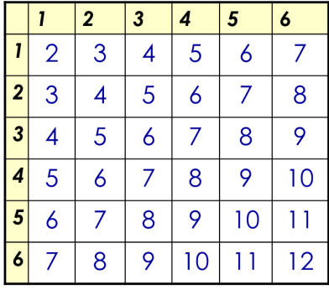
- you get doubles or a sum of 4

- you get doubles or a sum of 7

- you get a 5 on the first die or you get a 5 on the second die.

Use the Venn Diagram to answer the following questions.
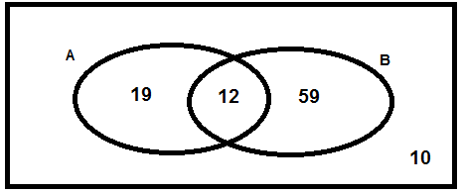

- P(A)
- P(B)
- P(B)’
- P(A ∪ B)
- P(A ∩ B)

- When you arrive home today, you find 27 cupcakes in a large circular plate. There are 13 that have icing, 11 have sprinkles, and 4 have both.
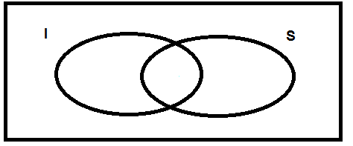

  - P(I)
  - P(S)
  - P(I ∪ S)
  - P(I ∩ S)

- The probability that it will snow on Saturday is 25%. The probability that it will snow on Sunday is 29%. The probability it will snow both days is 12%. What is the probability it will snow on Saturday or Sunday. Hint: Draw a Venn Diagram.

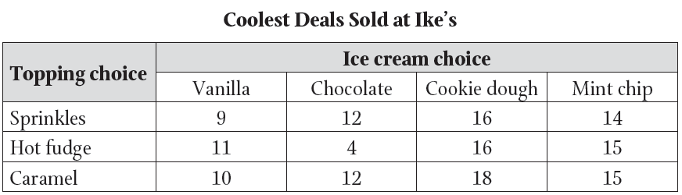
- Use the data below to find each of the following probabilities.

  - P(Chocolate)
  - P(Chocolate)’
  - P(Sprinkles ∩ Cookie Dough)
  - P(Caramel ∪ Vanilla)
Conditional Probability
The table shows the results of a poll of randomly selected high school students who were asked if they prefer to hear all school announcements in the morning or afternoon.
 | Underclassmen | Upperclassmen
Morning | 8 | 14
Afternoon | 18 | 10

- Find P(Morning|Underclassmen)
- Find P(Afternoon|Upperclassmen)

The table shows the results of a customer satisfaction survey for a cellular service provider, by location of the customer. In the survey, customers were asked whether they would recommend a plan with the provider to a friend.
 | Arlington | Towson | Parkville
Yes | 40 | 35 | 41
No | 18 | 10 | 6

- Find P(Yes)
- Find P (Yes|Arlington)
- Are the 2 probabilities the same?

Roberto is the owner of a car dealership. He is assessing the success rates of his top three sales people in order to offer one of them a promotion. Over two months, for each attempted sale, he records whether the sales person made a successful sale or not. The results are shown in the cart below.
 | Successful | Unsuccessful
Becky | 6 | 6
Raul | 4 | 5
Darrell | 6 | 9

- Find P(Successful|Becky)
- Find P(Unsuccessful|Darrell)

